Tips on Using the Digital Microscope and Software
- Turn on computer.
- Look for Dinocapture 2.0 icon on PC desktop. 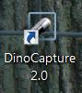 It’s called DinoXcope on Mac.
- Double click it.
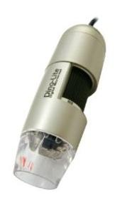
Trying out the Microscope
  - Carefully remove microscope from the box.
  - What parts of the microscope are there?
- Clear plastic where LED lights and lens are located. You can put this on top of an object, however, no fingers in it and do not submerge it in water.
- Black dial- focuses the microscope. The range of focus is 10-250 times. You can read the magnification as a number on the dial. When you put this away or get ready to start you should always be sure it is set back at low power or the 4 and 2 square grids near 30x.
- USB cord that attaches to the appropriate port on the laptop (It may be worth color coding this on the laptop and the USB plug so children know where it plugs in.)
  - Set up the holder for the microscope.
  - Place microscope in stand holder so dial portion is facing out.
- Check the black dial on the side, it should be set at low power or the 4 and 2 square grids near 30x.
- Plug the USB into the correct outlet on the computer
  - Try taking a picture of an object of your own.
Make sure the dial is set to the low power or the 4 and 2 square grids near 30x.
  - Place your object on the table.
  - Get your microscope as close to the object as possible or on the object. Avoid putting anything up into the microscope.
  - Try focusing in until the image is clear. Move dial slowly. This is low power. Read the number on the dial.
    - If things blend with the background, try placing either dark paper or white paper under the object to increase the contrast.
  - You can also take a look at the settings icon as you take the picture
  - To take a picture. Look for the camera icon and click it.
    - If you decide to hold the camera on an object, you will need someone else to snap the picture.
  - Move the dial slowly to focus even closer to the object. Focus using the dial. Take a picture of the object when focused on high power.
Moving & Saving Photos within Dinocapture 2.0
      - The photos will all stay in a folder within Dinocapture until you decide to move them.
      - Select a picture
      - Right click and save the picture to a folder on your desktop
      - It will save as a jpeg that you can insert into other documents.
Organizing Folders in Dinocapture
- You can create a folder to organize pictures on the desktop you are working from. This might be useful if you are using the microscope for different units or projects.
- Click the folder icon
- Select “folder manager”
- Click “new” and create your folder name
- Then click “select”
- The new folder should come up on the left, ready to save new photos.

Other things: You can write on and draw on photos within Dinocapture 2.0. I have found there are glitches with this and it is not so easy to manipulate text and shapes after you create them. It is easier to manipulate in Power Point or other program.
There is a users guide “i” , the last icon in the top left of the window. As you read through be aware that the info. may not be consistent with this version of the digital microscope.
Online source for downloading software
http://www.dinolite.us/all-downloads
Caring for the Microscope
If you need to clean your Dino-Lite, first attempt to gently blow off any dust or other contaminants with compressed air. If no compressed air is available then try to lightly brush off any lose debris with a fine brush (a makeup brush will work well).
If you need to clean the optical part, use a cotton swab that is dipped in standard optical lens cleaning solution. To make your own optical lens cleaning solution, mix one part alcohol (C2H5OH) with three parts ether ((C2H5)2O). Simply saturate a cotton swab and gently wipe the lens surface clean. Avoid touching the surface of the lens with your finger tips.
DO NOT twist or spin the lens off. This will affect the accuracy of the magnification rate.

Field of View on Computer/Laptop
- All photos are stored in gallery as thumbnails here in dinocapture. The video tab contains any videos you take.
- The folder is there if you create a folder in your dinolite folder on the computer. You can select this and put pictures into it. I have found it difficult to manage this way? I find it easier to save a picture I have taken into a spot or folder on my computer.
- i is for help and information about dinocapture software
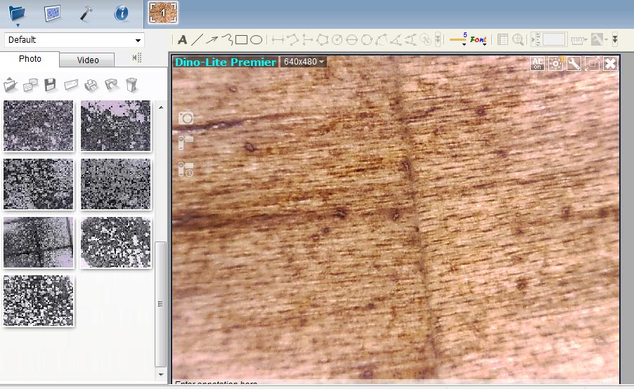
- None of the smaller icons work with this model

These icons show up on the computer screen in field of view
Camera to take photo
Video to make a video

Timelapse pictures

These icons are for altering the lighting and contrast of
your images.
AE auto exposure
Circle: turn LED lights on/off.
Wrench: alter image settings
X means close out of the field of view
Box/arrow: makes field of view on computer larger/smaller

Text Line Arrow Free line Shapes thickness Font/line color
of line

After you save your image in the gallery, you could add text to it. As I mentioned I find doing it with the software a bit finicky. These are the options that work with AM3011 series.
Double click and go.
First select font color and style. And thickness of lines. These two icons are in color.
Then decide on one of the following:
Font, lines, arrows, free lines, and shapes.
Save in a folder of your choice for later. The saved picture may not show up in the dinolite gallery of thumbnails on the side.

