Lesson 5-6 Sledding
Objectives:
- Finalize Re-designs
- Reflect on engineering sleds
- Perform final tests
- Measure distance traveled
- Measure time in seconds
- Observe what engineers do.
Materials
Extra pebbles recycled materials for sleds Tools
Video clips from pbs kids Dragonflytv http://pbskids.org/dragonflytv/scientists/index.html
Prep
Test on digital scopes
Create heavy sled and test with and without pebbles- make it too heavy!
Print student test sheets
Procedure
Engineer Careers: During down time, have the children choose an engineer and watch a 2-3 minute video clip. Ask- what they liked? What did the engineer do? Video clips from pbs kids Dragonflytv http://pbskids.org/dragonflytv/scientists/index.html

Concept Application
- Goals
- What we learned and what we need to do from our sled tests
Our ideas from discussion:
  - Some were unsafe
  - Sturdier gliders
  - Add more weight
  - Others?
- Or are some sleds too rough on the bottom and creating friction?
- Work on sleds
- Retest! Our ideas for what we need to do to make them faster
  - Big hill
  - Extra weight?
- Testing
  - Assign jobs in groups of 3: recorder, measurer, tester
- Reflecting
  - Review engineering design and discuss from weeks 1-5 what we did as engineers
  - Reflect and draw or write their favorite part of engineering

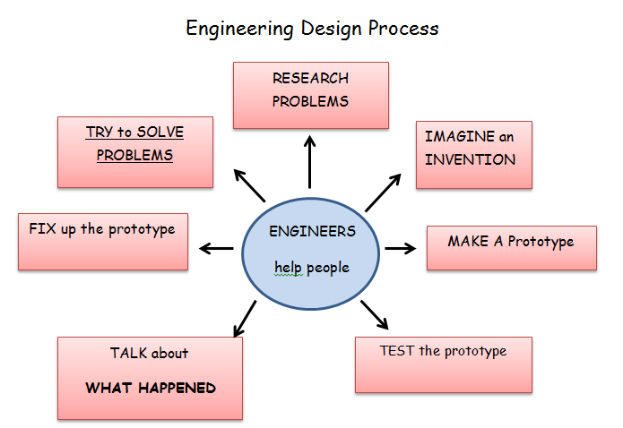

What I liked most about engineering

Interview/Discussion Progress Checklist
(Teacher observations and assessment during lessons 3-6)

FORCES | Completes task with assistance | Completes task independently
Can give an example of a force
Can describe force as push or pull

Can describe how objects move

Can tell gravity is the force that moves the sled down hill

Can tell identify friction as a force that slows motion
- Mention smootheness
- Mention roughness

Sled Engineering

Can identify where friction happens on moving sled

Can explain what materials help prevent friction

Can explain where extra weight is placed to make a sled move fast

Can explain how the sled stays balanced

Other Skills Science With assistance Independently
Communicates ideas clearly
Makes predictions based on evidence
Reads tape measure properly
Writes numbers
Draw inferences based on evidence
Makes observations

