Connections between Science and Art
Strategies that promote using art to do science
Thinking ‘like a scientist’ and scientific investigating are not common activities. Children have an innate curiosity to discover but their ability to investigate is often limited. For example, children often observe one attribute of an object when asked to make observations or describe an object. We need to encourage children to consider other attributes and use their senses. One way to encourage this type of thinking is to use art by asking open-ended guiding questions about the elements of art.
The elements of art include: shape, form, line, color, texture, space and value. These elements provide children with a lens for making detailed observations. Try these strategies below during play time, recess, centers or meeting times – have children observe objects and help them describe and ask questions, using the elements of art.
Inquiry Skills
Using the elements of art, we can help children develop their inquiry skills
MA Preschool STE Learning Standards
--Record observations and share ideas through simple forms of representation such as drawings.
-Ask and seek out answers to questions about objects and events with the assistance of interested adults.
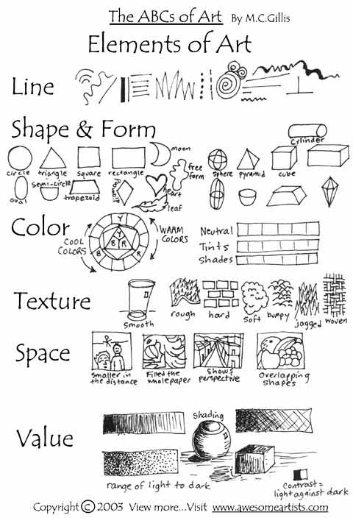
Guiding children to use elements of Art as they perform inquiry skills
Attention Focusing Questions help children take notice of details easily overlooked. These types of questions help develop better observation skills.
“Do you notice any colors on the head of the bird? Wings of the bird?”
“What shapes do you notice on the wings? On the tail of the bird?”
“What do you notice about the shapes of lines in the bark? How does it feel? What other shapes do you notice in the bark as you look closely?”
Measuring and Counting Questions allow children to use new skills and new instruments. These types of questions help build a child’s confidence because children obtain an exact answer.
“How many shapes do you see…?” “How long are the lines…?”
“How many different shapes can you find?” “How many lines or shapes do you see?”
Comparison Questions help children observe, notice patterns, classify, and focus skills. These types of questions also help children recognize differences as valuable information. These questions can also guide children as they “tell what happened” (or draw conclusions).
“How can we tell the difference between these two birds?” Are their colors the same? Their size the same? DO they have the same marks or lines?”
“Is the color/shape/size/texture the same on the top/bottom? Front/back? ”
“Do you notice any pattern between the lines and circles...?”
Explanations Based on Scientific Knowledge allows children to see the relevance of facts, concepts, and principles that they are taught. They need to be guided to consider what they know or what they may need to learn to explain what they observed. Questions can help children access prior knowledge and construct explanations that may relate to their observations.
“How will the shapes, lines, or colors help us remember that the bird is a robin?”
“ How will we know if we find a robin’s feather or a turkey feather?”
“What does the color and shape of the line tell a doctor about this bone?”
What can children do?
Make scientific illustrations of an object: Have them trace the outline of an object. Or create a sculpture out of clay. Or a painting. Have them draw their observations in the space and talk about the different parts of the object (tail, wing, bones, etc… so they use terms and communicate their ideas.) Sketch in a science notebook.
The more you and your children use art elements in observations on a daily basis, talking and creating art, the better detailed observations they will make. Before you know it they will be using these terms as they make their own observations. If you have an art teacher at your school – this might be a way to collaborate on a project together. They can teach elements of art that can be reinforced as you develop science inquiry skills.
Resources for Lesson Ideas & Strategies:
Earlychildhood
Observing Birds: Ashbrook, Peggy (2007). Birds in Winter. Science and Children. February, pgs 16-17
Drawing movement: Ashbrook, P. (2012). Drawing Movement. Science and Children. November, pgs. 30-31.
Rodgers, L. & Basca, B. (2011). Nurturing the child scientist. Science and Children. November, pgs.53-55.
Elementary
Cobb., W.H. Aliello, M.P., Macdonald, R., & Asplund, S. (2014). Art and the Cosmic Connection. Science and Children. October, pgs 30-35.
Stein, M. McNair, S., & Butcher, J. (2001). Drawing on Student Understanding: Using illustrations to invoke deeper thinking about animals. Science and Children. January, pgs 18-22.
Porter, K., Yokoi, C., Yee, B. (2011). The art and science of notebooks. Science and Children. October, 42-46.
For examples of pictures and more ideas about ART and Science visit http://maryhattonscience.weebly.com/science-and-art.html

Weather – After you read a story try looking at a satellite photo on weather.com!
Some meteorologists use satellites to monitor approaching storms. What shapes do you see in the clouds on a nice day? On a day when we had a hurricane?

Deforestation patterns
Some scientists, study satellite data to look at how the earth is changing or being changed. The state of Rondônia in western Brazil — once home to 208,000 square kilometers of forest (about 51.4 million acres), an area slightly smaller than the state of Kansas — has become one of the most deforested parts of the Amazon. In the past three decades, clearing and degradation of the state’s forests have been rapid: 4,200 square kilometers cleared by 1978; 30,000 by 1988; and 53,300 by 1998. By 2003, an estimated 67,764 square kilometers of rainforest—an area larger than the state of West Virginia—had been cleared.
Deforestation follows a fairly predictable pattern in these images. The first clearings that appear in the forest are in a fishbone pattern, arrayed along the edges of roads. Over time, the fishbones collapse into a mixture of forest remnants, cleared areas, and settlements. This pattern follows one of the most common deforestation trajectories in the Amazon. Legal and illegal roads penetrate a remote part of the forest, and small farmers migrate to the area. They claim land along the road and clear some of it for crops. Within a few years, heavy rains and erosion deplete the soil, and crop yields fall. Farmers then convert the degraded land to cattle pasture, and clear more forest for crops. Eventually the small land holders, having cleared much of their land, sell it or abandon it to large cattle holders, who consolidate the plots into large areas of pasture.

Moon After you read about the moon, try looking at a picture of the moon taken by a telescope. What do you and scientists see in the moon?
Astronomers and geologists look at the surface of planets to learn how they are similar or different from the earth. Is there life or are there similar structures on the earth’s surface?

What shapes can you find on the moon?
Many of the circles with lines are caused by meteorites hitting the moon. The pattern of lines tells astronomers how fast or big the meteorite hit. Are there areas where you see more circles or less? What might that tell us?

Guiding questions:
“Do you notice any colors on the head of the bird? Wings of the bird?”
“What shapes do you notice on the wings? On the tail of the bird?”

Try matching to shapes or try creating a matching shape!

“How can we tell the difference between these two birds? Are their colors the same? Their size the same? DO they have the same marks or lines?”

“What do you notice about the shapes of lines in the bark?

Try matching to shapes or try creating a matching shape!

How does it feel? What other shapes do you notice in the bark as you look closely?”

“What colors do you see in the bone?”
“Are all bones the same shape?”

Try matching to shapes or try creating a matching shape!

“How is the pattern on X-Ray of the … like (different from) the other one?”

