Sleds and Motion
Day One: What’s wrong with this sled?
Objectives:
- Preassess students: what students know about motion
- Students will explore making objects move
- Students will describe how things move and define this as force
- Learn about engineering design process and begin to research the problem.
Materials:
-Bag of recycled objects: cardboard, plastic plates, paper plates, plastic containers, egg cartons, milk cartons, craft sticks, yarn, pipe cleaners, boxes or various sizes, etc…
-Tools: glue, duct tape, markers, & scissors (teacher’s heavy duty scissors
and children’s scissors, small and saw & safety glasses for adult)
-Journal Title Page (name and drawing of “what we know about sleds)
-stop watches (2)
-ramp & objects (ball, cars, top, feather, roll, wagon, etc..)
Safety: Review proper use of materials and being safe. Having a second adult to help out with tools might be important.
Prep: Gathering recycled materials. Ask families to send items in.
Procedure:
- Introduction:
- What do you know about sleds?
  - Ask the children to draw ideas on a journal page. And then share together.
- Let’s see what you think about this sled. Show the children a sled problem
- Following the video clip, ask, “What happened?”
  - What did you notice about this sled?
  - List all ideas
  - What were some problems with this sled? (List)
  - What was good about this sled? (List)
- Let’s learn more about how sleds work

- Exploration
- In order for us to design our own sled to help Barbie, we need to do some research and brainstorm ideas. We need to think like engineers. (Introduce the graphic of engineering design process, see appendix. Discuss what we will do today.
- We need to learn a little more about motion or making things move. So we’re going to work like scientist to investigate how motion works.
- We’re going to explore motion. (We had two adults, so children could work in smaller groups)
  - Ask- what is motion?
  - In groups
We will work in design tems to investigate motion of objects and the forces that cause motion
    - Pass out an object to each child (ball, feather, car, block, top, etc…)
    - Predict & investigate
      - How do you think you can make this object move?
      - Let’s find out?
      - Record predictions
- Concept Introduction
    - Describe our observations
Terms to be introduced when the children describe the different motions. Motion is caused by a force. Force is a push or pull action- identify with motions they create- push ball, pull string, etc... Motion terms: push, pull, roll, slide, straight, circular, crooked
Guiding questions to discuss as you introduce the terms:
      - Did it do what you predicted?
      - How did it move?
      - Teacher record ideas in table.
    - Allow the children to take turns testing out movement of objects and discussing together.
    - Summarize our discoveries:
      - What shaped objects rolled?
      - What shapes are the objects that slid?
      - How will this help us think about what we need to build a better sled? What kinds of motion did we see in Sarah’s sled? Is this how we think a sled should work?
    - Repeat with Ramps
    - Discuss or draw and interview: “What I learned about motion today…”
      - The force that lets things move- when we push or pull on something. This is a force.
Homework: To think about sledding and observe your sled and bring in a picture of it. What do you think makes it a good sled?

Appendices: Discussion Prompts and Data Sheets

What do you know about sleds?

Take a look at Barbie’s sled project
What happened?

What were some problems with this sled?

What was good about this sled?

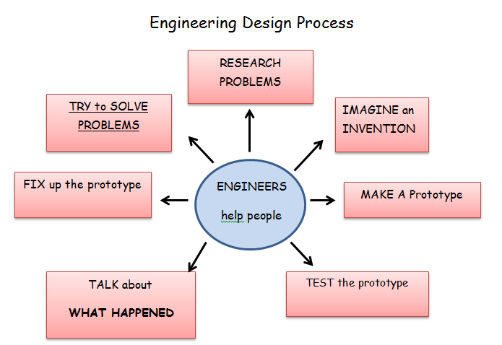

Engineers want to solve problems that will help people.
They research the problem.
They imagine their invention by brainstorming and using science&math
The make a model or prototype of their invention
They test it.
They talk about what happened and improve it to make it perfect
Then they fix it up or redesign it.

What does motion mean?
How do things move?

How do objects move?

Object | Predict  How can you make the object move? | Did it move?  Yes or No | How did it move?*
Cardboard roll

Ball
Feather
Block
Top

*Questions to ask if they don’t mention ideas for how things move: Ask did it … roll, slide, straight, circular, crooked? Did we push or pull the object?

How do objects move down a hill?
Object | Predict  How can you make the object move? | Did it move?  Yes or No | How did it move?*
Cardboard roll

Ball
Feather
Block
Top

*Questions to ask if they don’t mention ideas for how things move: Ask did it … roll, slide, straight, circular, crooked? Did we push or pull the object?

What I learned about moving things today…

